Week 3 Lab Task
Scanning & Enumeration
NIAI NAVTTC — Certified Ethical Hacker (CEH) Course
▶ Write a Scan Report
Record the following for each host found:
- IP address and hostname
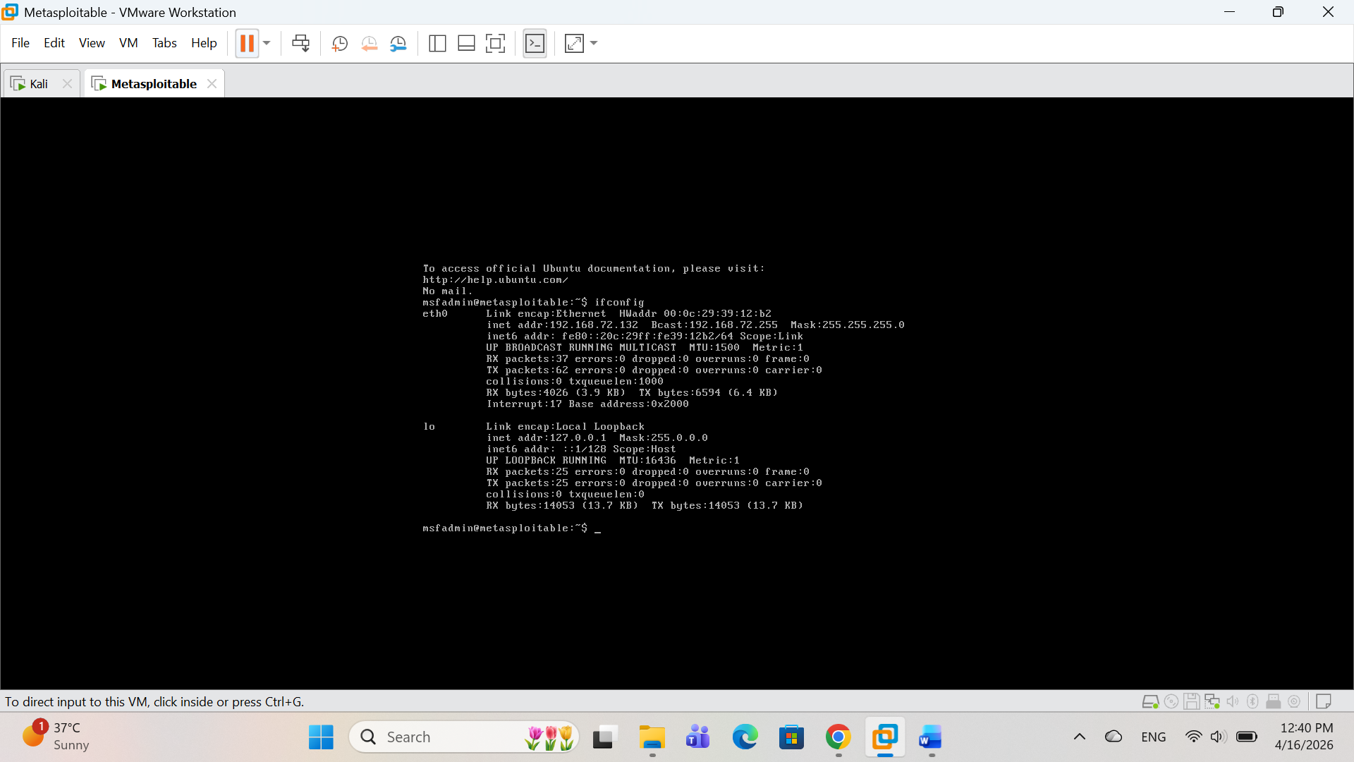
- Open ports and services running
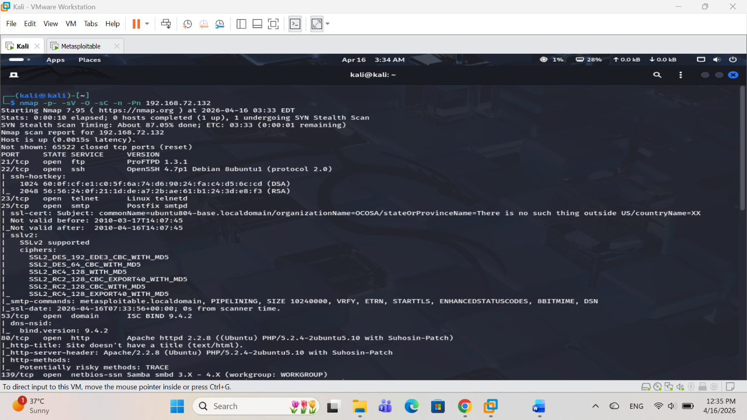
- Operating system detected

- Any vulnerabilities flagged by Nmap
Anonymous login for FTP is on that is vulnerable flagged by nmap.
- Any users/shares found during enumeration
